Myles J Sartor
Matthew Griffin
STAT100-0121
18 October 2023
Problem Set 5
1a. 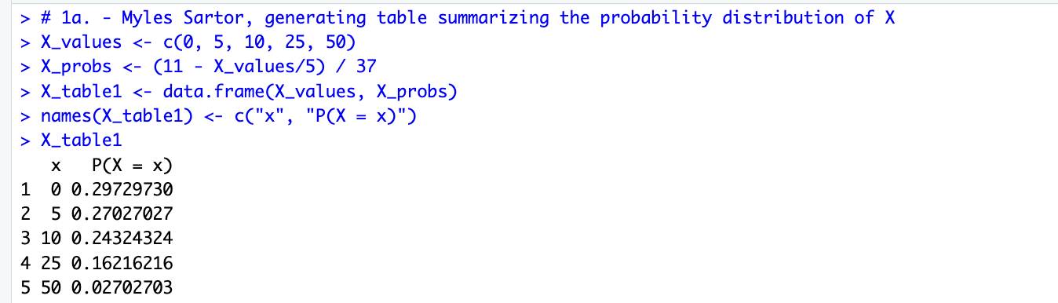
1b. The sum of all the probabilities adds up to 1, and every probability is between 0 and 1 as a result of this. Therefore, we can confidently say that this is a legitimate probability distribution since both properties for such have been met.
1c. 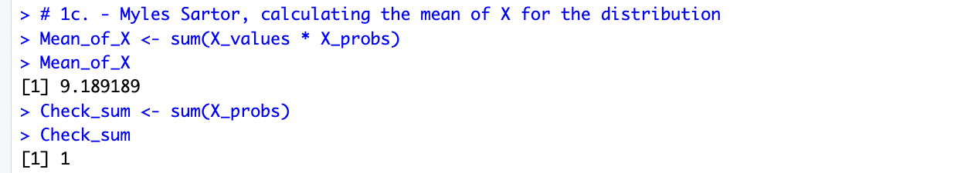
1d. The probability of winning more than $15 is 0.189, or 18.9%. I got this by adding up the probabilities greater than 15 P(x > 15). I got 0.16216216 + 0.02702703 = 0.18918919, which I rounded to 0.189 for the final answer.
2a. 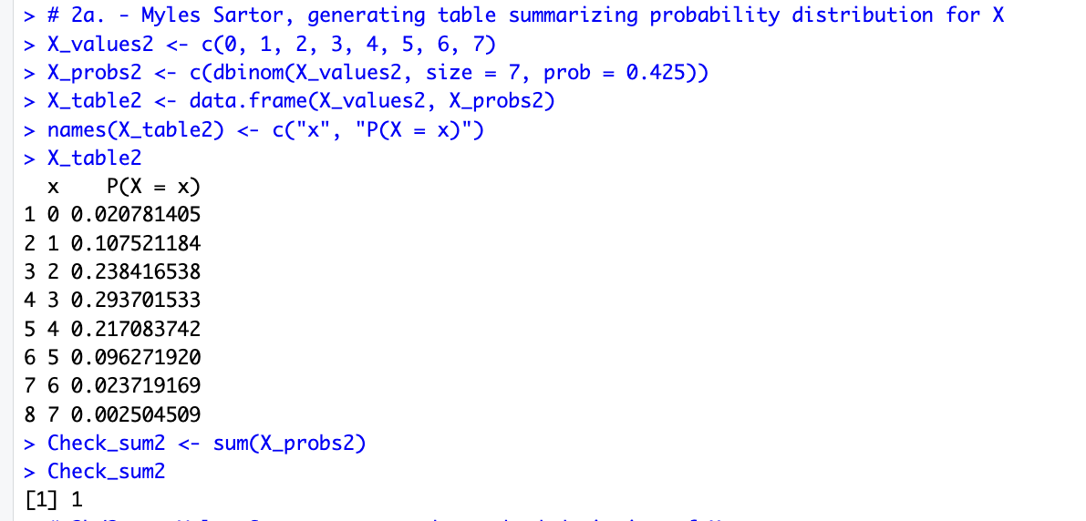
2b/2c.
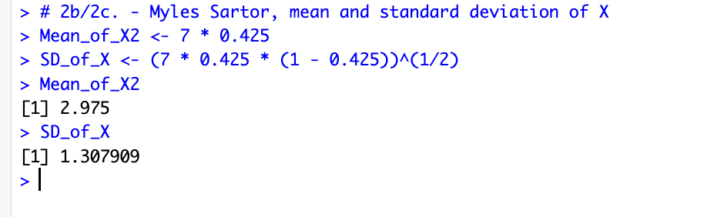
The mean of this binomial random variable is 2.975, based on the formula np, which is 7 * 0.425 in this situation (number * probability). The standard deviation is 1.307909, given by the formula sqrt(np * (1 – p)) , which is sqrt(2.975 * (1 – 0.425)) in this situation.
2d. The probability that exactly 4 out of 7 randomly selected college students smoke cigarettes is 0.217083742, which rounds to 0.217 or 21.7 %. P(x = 4), meaning probability would be equal to 4.
2e. The probability that less than four out of the seven randomly selected college students smoke is 0.66042066, which rounds to 0.660 or 84.7 %. P(x < 4). Added up all the probabilities under 4: 0.293701533 + 0.238416538 + 0.107521184 + 0.020781405 was what I added, P(x=0, 1, 2, 3), all x values under 4.
2f. The probability that between 3 and 5 of the seven randomly selected college students smoked is 0.607057195 which rounds to 0.607 or 60.7 %. P(x = 3) + P(x = 4) + P(x = 5). P(3 <= x <= 5). 0.293701533 + 0.217083742 + 0.096271920 was what I added. All x values between 3 and 5 (4), including 3 and 5.

